Appendix 1. The steady state and calibrated parameters

The DSGE model implies a number of long run restrictions for growth rates, nominal shares and price ratios. The determination of the steady state of the model is described below, where steady state is denoted by the endogenous names without the index t.

Long run growth rates and inflations are calibrated as follows:

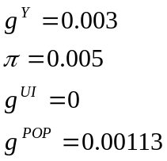

The steady state of real per capita GDP growth rate determines all the real growth rates of the model, except for investment, which is given by:
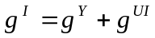.

The steady state of GDP deflator inflation defines the steady state of all inflation rates in the model and also of nominal wage inflation, as:
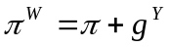

The technology growth is determined by:
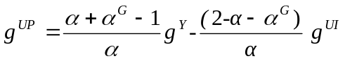

Nominal interest rate is given by:
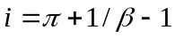

The model allows for a generalised case, where the rate of time preference in the domestic and foreign countries is different, implying different steady state nominal interest rates. The net foreign asset share to GDP is thus given by:

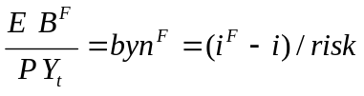

This implies a steady state level for the nominal trade balance share:
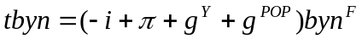

By combining the GDP equilibrium condition and equations (21-24), the identity 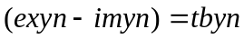 can be expressed only in terms of trade balance, real exchange rate and foreign to domestic GDP ratio, ywy. The latter ratio is calibrated at 1, allowing to obtain ER from tbyn. From this all the price ratios can be determined as:
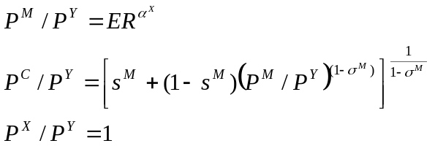
where 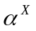 is the share of intra trade, calibrated at 0.5. The import and export shares are also determined as:

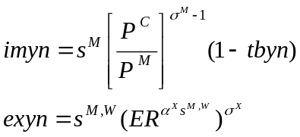

In the case when the domestic rate of time preference is equal to the one of the rest of the world, the above listed steady state conditions simplify to:
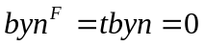
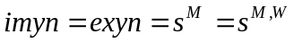.

From the closure of the trade balance equations, the steady state of the domestic variables can be finally solved. First, from capital accumulation, we get:
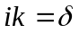
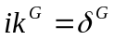
and, from capital FOC, we also get:
This defines the nominal investment share:
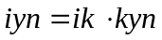
The government shares are calibrated to match observed ratios:
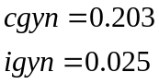
The consumption share is thus given by:

The wage share is simply given by:
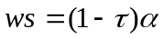

Calibrated constants are:
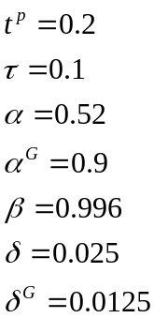

where is set to match the nominal wage share at the end of the sample, while  is set to match the very small difference in the levels of interest rate and inflation in the end of sample.

The steady state of employment rate is set at 0.65. This implies a restriction for , which is a function of the steady state of employment rate and of other model parameters.
The steady state of ucap is set at 1, implying
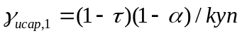

The steady state of the GDP share of government debt byn is set at 2.4 (60% yearly), while the level of nominal transfer share is estimated, implying the steady state of lump sum tax:
where
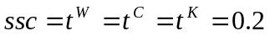

This allows to determine the steady state of the share of liquidity constrained consumers
and hence the non-liquidity constrained ones are:
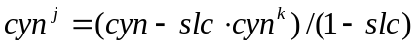.

Calibrated parameters

The parameters listed in Table A1 are calibrated and kept constant over the estimation exercise. The reaction of wage taxes to output gap 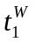is set to 0.8, following OECD estimates.

TABLE A1 Calibrated parameters

Structural parameters |  | Steady states
 | 0.52 | 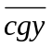 | 0.203
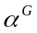 | 0.9 | 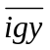 | 0.025
 | 0.996 | 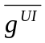 | 0
 | 0.025 | ,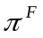 | 0.005
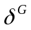 | 0.0125 | 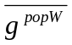 | 0.00113
τ^{B} | 4.e-6 | 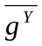,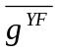 | 0.003
τ^{DEF} | 4.e-3 | 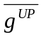 | 0.0024
b^{T} | 2.4 | 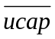 | 1
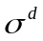 | 10 | 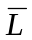 | 0.65
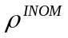 | 0 | 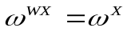
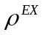,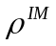 | 0.975 |  | 1.6
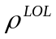 | 0.99 | TRWS | 0.36
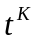,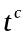,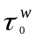 | 0.2
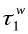 | 0.8

Other parameters are determined according to steady state constraints:
- 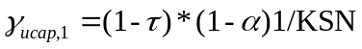, determined in order to assure the steady state constraint ucap = 1, where 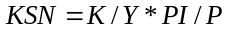 is the nominal capital to GDP share.
- is determined in order to assure the steady state condition 